Non-volatile Memory, Possible NAND Flash Replacement

Computer Architecture

Shalin Patel, 0194037

Monroe College, New Rochelle

One Page Report

Non-volatile Memory (NVM) is a kind of PC memory that has the ability to hold the saved data regardless of whether the power is turned off. Unlike to volatile memory, NVM does not require its memory data to be periodically refreshed. It is generally utilized for optional storage or long-term steady storage. Non-volatile Memory is very well known among advanced media, it is broadly utilized as a part of memory chips for USB memory sticks and computerized cameras. Non-volatile memory annihilates the requirement for relatively slow types of secondary storage systems, including hard disks. Non-volatile memory is also known as non-volatile storage.

NAND flash memory is a sort of non-volatile storage innovation that does not require power to hold information. It utilizes drifting entryway transistors that are associated in a way that the subsequent association looks like a NANA door, where a few transistors are arrangement associated and a bit line is pulled low just when all word lines are at a high state, thus the name. The innovation is utilized as a part of basic storage gadgets, for example, flash drives, solid state drives and memory cards. NAND flash memory is the most widely recognized kind of memory being utilized as a part of the mass market in light of its reasonableness, storage density and access speeds. It is found in most present-day PDAs as the primary and even as the secondary storage, in memory cards and in solid state drives as a PC stockpiling, not at all like NOR flash, which acts like RAM and is somewhat costlier.

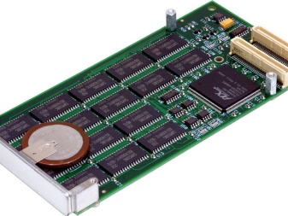 Non-volatile Memory 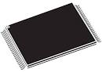 NAND Flash Replacement

References:

Margaret R. (November 2017). Non-volatile memory(NVM). Retrieved from: <https://searchstorage.techtarget.com/definition/nonvolatile-memory>

Non-volatile memory(NVM). Retrieved from: <https://en.wikipedia.org/wiki/Non-volatile_memory>

Margaret R. (November 2017). NAND flash memory. Retrieved from: <https://searchstorage.techtarget.com/definition/NAND-flash-memory>

Flash Memory. Retrieved from: <https://en.wikipedia.org/wiki/Flash_memory>